Yun-Fu Liu, *Member*, *IEEE*, *Chang-Chun Chu, *Jing-Ming Guo, *Senior Member*, *IEEE*, and Xian-Sheng Hua, *Fellow*, *IEEE*

Unpaired Object Transformation Based on Generative Adversarial Networks

# **Abstract**

*The existing approaches of object transformation based on generative adversarial networks (GANs), in case of not providing the paired images and annotating the object of interest in the training and testing phases, the synthetic images of theirs would have significant color change in an undesired region, such as background. Considering these problems, an effective method is proposed to reduce the color distortion in the background and manual annotation cost. The strategy is to generate the rendering masks via residual connections and take their uniformity into consideration in the training process to preserve the original contents of images without any paired training data and predefined region. As demonstrated in our experimental results, the qualitative and quantitative evaluation outperforms previous works, and our approach can efficiently decrease artifacts and conspicuously preserve more visual information in the region of background in regard to the visual perception in comparison with alternative methods.*

# **Introduction**

The primary framework of GAN is proposed by Goodfellow et al. [1]. The conventional GAN utilizes adversarial loss to make the distribution between given real samples and synthetic ones as close as possible, but the objective of discriminator is to distinguish real samples and synthetic ones as much as possible. In subsequent research, GANs are widely adopted for various image processing tasks such as image generation [2, 3, 4, 5, 6, 7], image inpainting [8], image edition [9], super resolution [10], future prediction [11], semantic segmentation [12, 13, 14], video scene parsing [15], as well as image-to-image translation [16]-[24]. For the purpose of dealing with the problem of the mode collapse and increasing the stability in the training process, a variety of training strategies have been proposed, such as WGAN [25], Improved-WGAN [26], Least Squares GAN [27] and loss-sensitive GAN [28]. In this work, our aim is to address the problems in the task of image-to-image translation based on generative adversarial network.

Image-to-image translation with paired dataset is trained from joint distribution [16, 29, 30, 31, 32, 33, 34, 35, 36, 37, 38] and widely utilized in many kinds of conditions, such as image to semantic labels and photograph to edgemap. For example, pix2pix [16] utilizes conditional generative adversarial network to train and figure out the mapping function, that is used to translate from input to output images. However, developing pixel-wise labeling datasets are considerably expensive and time-consuming. Unpaired image-to-image translation [17, 18, 19, 20] is trained from marginal distributions and are more applicable than the paired one. The reason is that many kinds of objectives are difficult to define pixel-wise annotations exactly, such as natural object transformation. CycleGAN [17], DiscoGAN [18], DualGAN [19] and Liu et al. [20] achieved the task of image-to-image translation with unpaired dataset. However, CycleGAN [17] has demonstrated significant color distortion in the region we are not desired to translate in the task of unpaired object transformation. The reasons for this phenomenon might be that the independence between objects could not be learned well by the network.

Yun-Fu Liu and Xian-Sheng Hua are with the DAMO Academy, Alibaba, Hangzhou, China (e-mail: yunfuliu@gmail.com, huaxiansheng@gmail.com).

Chang-Chun Chu and Jing-Ming Guo are with the Department of Electrical Engineering, National Taiwan University of Science and Technology, Taipei, Taiwan (e-mail: m10507502@mail.ntust.edu.tw, jmguo@seed.net.tw).

In the proposed approach, we aim to make the network to understand the structure of an indicated attribute of the object, hence the attributes of our interesting objects in the images are independent to each other. Therefore, we can translate the specific object to another one, and preserve the contents of original images in the untranslated area. The contributions of this paper are organized as below:

1) The residual connection is used to yield the synthetic mask in the generator, and preserve the original spatial and color relationships in the feed-forward phase effectively.

2) The uniform loss is utilized to evaluate and optimize the uniformity of synthetic masks yielded by the generator in the training phase, and prevents some random artifacts.

3) We increase the background similarity, and generate higher quality and more realistic images effectively in comparison with the state-of-the-arts approaches in regard to the qualitative and quantitative analysis.

The rest of this paper is organized as follows: Section 2 gives an overview of the existing image-to-image translation methods. Sections 3 and 4 elaborate the details of the proposed method and the implementation details, respectively. Finally, Section 5 demonstrates the experimental results, and Section 6 draws the conclusions.

# **Related works**

The approaches of unpaired image-to-image translation [17, 18, 19, 20] were demonstrated many kinds of results in distinct tasks, including style transfer and object transformation. It alleviated the requirements of pixel-wise annotations and learned from marginal distributions.

## **2.1. Image-to-image translation with unpaired dataset**

The concepts of CycleGAN [17], DiscoGAN [18] and DualGAN [19] are slightly similar, all of which train two generators and two discriminators, and yield cross-domain images. The cycle-consistent adversarial network is adopted by CycleGAN [17] to train the model of unpaired image-to-image translations. The concepts of Johnson et al.[35], Markovian Patch-GAN[10, 16, 39] and Least Squares GAN [27] are used in the architectures and loss function of CycleGAN [17]. In the training process of CycleGAN [17], each domain adopts different discriminator to evaluate whether the distributions of generated images are close to the distributions of real ones. The optimizations of two GANs are conducted separately. The generated images are pushed back to the primitive domain as the reconstructed ones, and the cycle-consistency loss is the difference between input images and reconstructed ones.

In the training stage of DiscoGAN [18], two distinct GANs including one for mapping *A* to *B* and the other for mapping *B* to *A* are coupled and trained together, and each of them can ensure the effectiveness of translating to the opposite domain. The optimizations of DualGAN [19] adopt the uncoupled strategy which is similar with CycleGAN [17]. The loss functions and architectures of DualGAN [19] use Least Squares GAN [27], WGAN [25] and U-shaped net [16, 40]. Liu et al.[20] combines the weightsharing strategy of CoGAN [41] with variational autoencoders [42].

In the proposed method, we focus on the task of object transformation with unpaired dataset [17], and alleviate the color distortion in the region of objects we are not interesting to translate. Unlike previous work, our intentions are to synthesize a rendering mask instead of an entire image and improve the propagation of the contents in the original image via residual connections, and conceive the uniformity of the rendering mask as one of our objective function for the purpose of reducing the color change in the region of back-ground and random artifacts.

## **Background color distortion problem**

CycleGAN [17] demonstrated several impressive results in many tasks, such as style transfer; however, the outcomes of CycleGAN [17] in natural object-to-object color translation would give rise to obvious distortion in the background. Liang et al. [43] proposed supervised approaches to reduce the distortions in the region of background; however, they needed to define the region of interest manually. Due to the requirement of manual annotations in advance, Liang et al. [43] is not our competitor. The goal of AttentionGAN [51] is similar with ours; however, they utilized the two-stage method to solve color distortion in the background. The attention network and transformation network are utilized to find the region of interesting objects and translate the objects, respectively.

In this paper, we present the one-stage approach which do not need to define the region of our interesting manually in training and testing stages in advance, and infer probability distribution functions and appropriate features that are used to transform one image to the other image subset with the particular attribute based on conditional GAN. Our funda-mental objectives are to maintain the content between the original sample and the forward-backward mapping one in the training stage, and reduce the range of possible mapping functions. This concept is similar to cycle-consistency loss [17]. We aim to alleviate the color change of objects not belonging to our interesting region. In relevant with this, the architecture of the generator we utilize are to yield the rendering mask in the generator rather than the holistic image, and take the uniformity of rendering masks into consideration in the training stage. We compare our method with previous works, including CycleGAN [17] and AttentionGAN [51]. The quali-tative and quantitative results demonstrate the effectiveness of object transformation and exceed CycleGAN [17] and AttentionGAN [51].



Fig. 1. The architecture and partial data flow diagram in training process. and *,*are presented the single generator and distinct discriminators.

# **Proposed method**

## **Network design**

Based on the framework of primordial GANs, the two players discriminator and generator are enforced to execute minimax game. , and denote the attribute set, the complementary attribute set of and the index of the given attribute, respectively. Our proposed method utilizes two discriminators , and one generator to produce synthetic images with the specific attribute ,. This ideal is inspired by conditional GAN [2, 3] using given desired attributes to guide the outcomes of the generator, and increases the capability of generalization and adaptability in the task of multiple translations. The architecture of the generator is based on the concept of autoencoder [44], which it can imitate the intermediate representation and is exploited to translate a sample with the one attribute into a sample with the indicated attribute. The fundamental architecture of the generator demonstrates in Fig.1. The detailed components of the generator and discriminator we utilize are introduced in section 4.1.

The training process of and are to discriminate the similarity of the attributes between given real images and synthetic ones. The optimization process of is to synthesize images and make the attributes between the given real images and synthetic ones closer as well as possible. We adopt these characteristics to train the mapping function between different attributes via given indicated attribute and training set without annotating the region of our interest in object or pixel level.

To eliminate the effect of random undesirable artifacts at the background, we also make use of residual connections in the architecture of generator to make the content of original image propagate more effectively, and evaluate and optimize the uniformity of rendering masks yielded in the generator as one of our objectives.

## **Loss function**

The adversarial loss function we adopt is based on adversarial loss [1] replacing the negative log likelihood with least square loss [27] for the reason that this loss can perform more stably in the training stage [23]. and are presented the generator and discriminator, respectively. andare termed as the images from real image set and , respectively. The objectives are expressed as below:

, (1)

where attempts to synthesize images  and make the distributions between the attribute of given real samples and the attribute of synthetic ones similar, while the goal of is to identify the attribute relationships between real images *y* and generated ones as much as possible. The optimization of generator and discriminator aims to minimize and maximize Eq.(1), respectively. However, the possible range of mapping functions would be too extensive to converge in the translation of multiple attributes.

and denote the real image set with attribute set , and the real image set with complementary attribute set of . and are termed as the real image with specific attribute from real image set *X*, and the real image with the complement of specific attribute from real image set , respectively. By means of embedding attributes ,in the generator , we can manipulate the attribute of outcomes , in the generator via multiple guides. This can assist the model to understand the intrinsic properties of image sets with distinct attributes effectively. For the purpose of distinguishing the attributes of real samples and synthetic ones, we utilize two discriminators and to measure the distribution between given real samples *,* and generated ones , . The objectives of single generator and two discriminators *,* become:

*.* (2)

In order to increase the clues to develop mapping functions , and decrease the possible space of mapping functions effectively, we utilize the cycle-consistency loss [17] to learn the relationships between given real images , and reconstructed ones , , and make the characteristics between them similar. The cycle-consistency loss is defined:

. (3)

The second last layer of the generator presented in Fig.1 yields the rendering masks , , which are used to transform real samples into synthetic ones , and translate synthetic ones into reconstructed ones via residual connections. , denote rendering masks of the complementary case via giving the other real image with the complementary attribute. The relationship between , and is defined:

*.* (4)

For the sake of the artifact reduction, we also take the uniformity of rendering masks as one of our objectives to optimize the generator:

. (5)

The integrated objectives are the combination of Eq.(2), Eq.(3) and Eq.(5):

. (6)

denotes a weight to control the importance of . In preliminary experiments, setting to 10 can obtain more stable and effective optimization and outcomes during training and inference phases.

The aims of generator and discriminators , are to minimize and maximize this objective, respectively, and then obtains as defined below:

. (7)

TABLE I. QUANTITATIVE ANALYSIS FOR HORSE→ZEBRA SELECTED FROM MSCOCO DATASET.

|  |  |  |  |  |
| --- | --- | --- | --- | --- |
| Method | mED | PSNR | SSIM | IN |
| CycleGAN [17] | 0.10012 | 20.440 | 0.69603 | 1.643 |
| AttentionGAN [51] | 0.03827 | 25.857 | 0.92180 | 1.273 |
| Proposed | 0.03047 | 29.694 | 0.96593 | 1.831 |

TABLE II. QUANTITATIVE ANALYSIS FOR ZEBRA→HORSE SELECTED FROM MSCOCO DATASET.

|  |  |  |  |  |
| --- | --- | --- | --- | --- |
| Method | mED | PSNR | SSIM | IN |
| CycleGAN [17] | 0.10656 | 20.277 | 0.69962 | 2.205 |
| AttentionGAN [51] | 0.04285 | 26.099 | 0.91933 | 2.331 |
| Proposed | 0.03735 | 27.525 | 0.92928 | 2.785 |

is our expected generator that it can yield the cross-attribute image via giving real one and the specific attribute, and preserve the background similarity, simultaneously.

# **4. IMPLEMENTATION DETAILS**

## **Network Architecture**

Our generator is based on the architecture of Johnson et al. [35]. It contains three stride-two convolutional layers, some residual blocks [45] and three fractionally-strided convolutional layers.

However, we substitute dense blocks [46] for residual blocks [45] for the reason that dense blocks [46] can make improvement in the propagation of information and gradients between layers via feature reuse utilizing dense connection of preceding layers, and reduce feature redundancy. The complete architecture of our generator includes three stride-two convolutional layers, three dense blocks [46] and three fractionally-strided convolutional layers.

The parameter settings of three stride-two convolutional layers and three fractionally-strided convolutional layers are equal to CycleGAN [17]. Each dense block contains 12 layers with growth rate with 12, and each layer includes Convolution(3×3, stride=1)-Instance Normalization-ReLU. The connection between dense blocks is to exploit transition layer including Convolution(1×1, stride=1)-Instance NormalizationReLU. The output layer of the generator is the addition of input image and rendering mask yielded by the last fractionally-strided convolution layer.

The architecture of the discriminator is to adapt PatchGANs [16, 17, 10, 39] which attempt to determine whether the single channel of the image patches are synthetic or real. We utilize this characteristic to classify the attributes of synthetic and real images via multichannel image patches. The overall architecture of the discriminator includes four blocks to extract features, and each block contains Convolution(4×4, stride=2)-Instance Normalization-LeakyReLU(slope=0.2). At the last layer, Convolution(1×1, stride=1)-LeakyReLU(slope=0.2) is used to produce *N* dimensional output. *N* denotes the number of all attributes, and is equal to 2 in our experiments.

TABLE III. QUANTITATIVE ANALYSIS FOR APPLE→ORANGE SELECTED FROM MSCOCO DATASET.

|  |  |  |  |  |
| --- | --- | --- | --- | --- |
| Method | mED | PSNR | SSIM | IN |
| CycleGAN [17] | 0.13498 | 18.375 | 0.66636 | 3.678 |
| AttentionGAN [51] | 0.05056 | 24.355 | 0.89716 | 4.057 |
| Proposed | 0.03532 | 30.192 | 0.95316 | 4.193 |

TABLE IV. QUANTITATIVE ANALYSIS FOR ORANGE→APPLE SELECTED FROM MSCOCO DATASET.

|  |  |  |  |  |
| --- | --- | --- | --- | --- |
| Method | mED | PSNR | SSIM | IN |
| CycleGAN [17] | 0.12761 | 18.622 | 0.67161 | 3.626 |
| AttentionGAN [51] | 0.04493 | 26.749 | 0.91718 | 4.175 |
| Proposed | 0.03731 | 30.291 | 0.94390 | 4.210 |

## **4.2. Training details**

In the preprocessing step, the real image is normalized into [-1, 1] for the purpose of mask operations in the architecture of generator. The batch size, height, width and channel of input and output images are equal to 1, 256, 256 and 3, respectively.

In order to mitigate the divergence in adversarial training process and artifacts, we utilize image buffer [23] to preserve 50 formerly synthetic samples, and select samples randomly in image buffer to optimize the network.

For entire experiments, we exploit ADAM algorithm [47] to train our network with batch size of 1. The learning rate is set to 0.0002 in the first 100 epochs, and uses a linearly decaying rate to goes to zero in the next 100 epochs. Early stopping criterion is based on the qualitative and quantitative evaluation to make sure whether the quality of synthetic images is in saturation. The model and experiments are implemented in TensorFlow.

# **5. Experiments**

## **5.1. Dataset**

The experiments are conducted equally under the datasets including Horse↔Zebra, Apple↔Orange collected from CycleGAN [17] and, MSCOCO [48], and CelebA dataset [49]. The size of training sets comprises of 939 samples for horse, 1177 samples for zebra, 996 samples for apple and 1020 samples for orange.

In order to demonstrate the effectiveness of reducing the color change in the region of uninteresting objects, and compare the background similarity with alternative methods, we also take MSCOCO [48] as our testing samples and the regions of interesting objects are given in the semantic segmentation tasks, such as horse, zebra, apple and orange. The size of testing sets for background similarity selected from MSCOCO [48] include 193 samples for horse, 181 samples for zebra, 149 samples for apple and 160 samples for orange.

## **5.2. Metrics**

Background similarity between the given source image and the corresponding transferred output is evaluated to quantify

TABLE V. ABLATION STUDY FOR HORSE→ZEBRA

SELECTED FROM MSCOCO DATASET.

|  |  |  |  |  |
| --- | --- | --- | --- | --- |
| Method | mED | PSNR | SSIM | IN |
| GAN | 0.22309 | 13.024 | 0.33119 | 1.104 |
| CAN+Cycle | 0.28815 | 10.640 | 0.27534 | 1.189 |
| GAN+cycle+RC | 0.04019 | 26.894 | 0.93047 | 1.498 |
| GAN+cycle+RC+Uni | 0.03047 | 29.694 | 0.96593 | 1.831 |
| GAN+cycle+RC+Uni  (resnet) | 0.03852 | 27.487 | 0.93866 | 1.716 |

TABLE VI. ABLATION STUDY FOR ZEBRA→HORSE SELECTED FROM MSCOCO DATASET.

|  |  |  |  |  |
| --- | --- | --- | --- | --- |
| Method | mED | PSNR | SSIM | IN |
| GAN | 0.19610 | 14.225 | 0.34816 | 1.074 |
| CAN+Cycle | 0.29096 | 10.885 | 0.29307 | 2.776 |
| GAN+cycle+RC | 0.05692 | 23.981 | 0.87531 | 2.692 |
| GAN+cycle+RC+Uni | 0.03735 | 27.525 | 0.92928 | 2.785 |
| GAN+cycle+RC+Uni  (resnet) | 0.04392 | 26.219 | 0.90201 | 2.778 |

the distortion. Three standard metrics, including mean Euclidean distance (mED), peak signal-to-noise ratio (PSNR), and structural similarity index (SSIM) [50], are considered in this work. Notably, the background region is determined by using the given segmentation mask ground truths. In addition, we utilized Inception score (IN) [7] to evaluate the reality of entire synthesized images.

## **Comparison**

We make a comparison between our method and previous approaches in the task of object transformation, including CycleGAN [17] and AttentionGAN [51] in regard to quantitative and qualitative assessment. The difference maps demonstrated in Fig. 2 are used to visualize the similarity between input samples and synthetic ones in the region of background. Our method can generate superior image quality, and the magnitude of difference maps is lower than alternative methods in terms of visual perception. For example, in the case of horse↔zebra, the color of grass and trees of our method can be preserved in comparison with previous works. In the case of apple↔orange, previous methods in the regions of the bird and other fruits introduce more visual artifacts than our method.

The quantitative similarity assessment in the region of background and the reality of synthetic images demonstrated in Tables I-IV is considerably superior to CycleGAN [17] and AttentionGAN [51] in different cases. To confirm the capability of image translation, we also conduct distinct kinds of cases as shown in Figs. 3-6. In Figs. 3-4, the color and the details of leaves, grass and trees of previous approaches can not be consistent in terms of visual quality. In Figs. 5-6, the previous works would produce some artifacts in the region of not belonging to our interesting object. Our method can efficiently reduce artifacts and obviously preserve more color

TABLE VII. ABLATION STUDY FOR APPLE→ORANGE SELECTED FROM MSCOCO DATASET.

|  |  |  |  |  |
| --- | --- | --- | --- | --- |
| Method | mED | PSNR | SSIM | IN |
| GAN | 0.24800 | 12.841 | 0.44412 | 3.264 |
| CAN+Cycle | 0.10701 | 19.851 | 0.67829 | 3.758 |
| GAN+cycle+RC | 0.05304 | 25.024 | 0.91084 | 4.044 |
| GAN+cycle+RC+Uni | 0.03532 | 30.192 | 0.95316 | 4.193 |
| GAN+cycle+RC+Uni  (resnet) | 0.04984 | 26.367 | 0.93679 | 4.170 |

TABLE VIII. ABLATION STUDY FOR ORANGE→APPLE SELECTED FROM MSCOCO DATASET.

|  |  |  |  |  |
| --- | --- | --- | --- | --- |
| Method | mED | PSNR | SSIM | IN |
| GAN | 0.23440 | 13.559 | 0.46625 | 3.567 |
| CAN+Cycle | 0.10466 | 20.931 | 0.7211 | 4.142 |
| GAN+cycle+RC | 0.04220 | 28.162 | 0.92328 | 4.130 |
| GAN+cycle+RC+Uni | 0.03731 | 30.291 | 0.94390 | 4.210 |
| GAN+cycle+RC+Uni  (resnet) | 0.04682 | 27.702 | 0.92935 | 4.181 |

information in the region of background in regard to the visual perception in comparison with alternative methods.

## **Ablation study**

For the sake of confirming the effectiveness of our proposed method in comparison with distinct settings, we analyze the effects of GAN loss (abbr. GAN) as defined in Eq. (2), cycle- consistency loss (abbr. Cycle) as defined in Eq. (3), the residual connection (RC) in the generator, and uniform loss (abbr. Uni) as defined in Eq. (5) in different tasks. We evaluate theperformance with different combinations, including GAN, GAN+Cycle, GAN+Cycle+RC and GAN+Cycle+RC+Uni.

In Tables V-VIII, the quantitative results of GAN+Cycle could be trade-off in distinct cases obviously for the reason that the original contents of the image would loss greatly when one image is passed through the generator to extract features and yield the other image with the specific attribute. Due to this situation, we adopt the residual connection (RC) in the generator to preserve the original information of images in the feed-forward phase. Additionally, the uniformity of rendering masks (Uni) are taken as one of our objectives to reduce some artifacts effectively.

In order to analyze the effectiveness between the residual and dense block in the architecture of generator mentioned in Section 4.1, we compare the background similarity and the reality of synthetic images of GAN+cycle+RC+Uni (resnet) denoted that the residual block similar with CycleGAN [17] is utilized in the generator, and GAN+cycle+RC+Uni denoted that the dense block is utilized in the generator. Due to the excessive utilization of the addition operation in the feature maps, the residual block in the hidden layers of the generator would lead to producing some feature redundancy and distortions in comparison with the dense block in the hidden layers of the generator.

# **6. Conclusions**

In this paper, we proposed a system to alleviate the problems of the color distortions on the task of object transformation based on generative adversarial network. The major concepts and aims of our proposed approach is to generate rendering masks rather than entire images to make the propagation of original essence of images more efficient, and take the uniformity of rendering masks into account in the training phase for the purpose of alleviating visual distortions in the region that are not our objectives and reducing random artifacts. We demonstrate and analyze the background similarity and the quality of synthetic images in regard to the qualitative and quantitative evaluation, and achieve significant improvement in comparison with the relevant methods.

# **References**

1. I. Goodfellow, J. Pouget-Abadie, M. Mirza, B. Xu, D. Warde-Farley, S. Ozair, A. Courville, and Y. Bengio, “Generative adversarial networks,” *Conference on Neural Information Processing Systems (NIPS)*, pp. 2672–2680. 2014.
2. M. Mirza and S. Osindero, “Conditional generative adversarial nets,” *arXiv preprint arXiv:1411.1784*, 2014.
3. A. Odena, C. Olah, and J. Shlens , “Conditional image synthesis with auxiliary classifier gans,” *arXiv preprint arXiv:1610.09585*, 2016.
4. E. Denton, S. Chintala, A. Szlam, and R. Fergus , “Deep generative image models using a laplacian pyramid of adversarial networks,” *Conference on Neural Information Processing Systems (NIPS)*, pp. 1486–1494, 2015.
5. A. Radford, L. Metz, and S. Chintala, “Unsupervised representation learning with deep convolutional generative adversarial networks,” *arXiv preprint arXiv:1511.06434*, 2015.
6. S. Reed, Z. Akata, S. Mohan, S. Tenka, B. Schiele, H. Lee, Z. Akata, and H. Lee, “Learning what and where to draw,” *Conference on Neural Information Processing Systems (NIPS)*, pp. 217–225, 2016.
7. T. Salimans, I. Goodfellow, W. Zaremba, V. Cheung, A. Radford and, X. Chen, “Improved techniques for training gans,” *arXiv preprint arXiv:1606.03498*, 2016.
8. D. Pathak, P. Krahenbuhl, J. Donahue, T. Darrell, and A. A. Efros, “Context encoders: Feature learning by inpainting,” in *Proceedings of the IEEE Conference on Computer Vision and Pattern Recognition*, 2016.
9. J.-Y. Zhu, P. Krähenbühl, E. Shechtman, and A. A. Efros, “Generative visual manipulation on the natural image manifold,” *European Conference on Computer Vision (ECCV)*, pp. 597–613, 2016.
10. C. Ledig, L. Theis, F. Huszar, J. Caballero, A. Cunningham, A. Acosta, A. Aitken, A. Tejani, J. Totz, Z. Wang, and W. Shi, “Photo-realistic single image superresolution using a generative adversarial network,” in *Proceedings of the IEEE Conference on Computer Vision and Pattern Recognition*, 2017.
11. M. Mathieu, C. Couprie, and Y. LeCun , “Deep multi-scale video prediction beyond mean square error,” *International Conference on Learning Representations (ICLR)*, 2016.
12. P. Luc, C. Couprie, S. Chintala, and J. Verbeek , “Semantic segmentation using adversarial networks,” *NIPS Workshop on Adversarial Training*, 2016.
13. P. Luc, N. Neverova, C. Couprie, J. Verbeek, and Y. LeCun, “Predicting deeper into the future of semantic segmentation,” *IEEE International Conference on Computer Vision (ICCV)*, 2017.
14. N. Souly, C. Spampinato, and M. Shah , “Semi and weakly supervised semantic segmentation using generative adversarial network,” *arXiv preprint arXiv:1703.09695*, 2017.
15. X. Jin, X. Li, H. Xiao, X. Shen, Z. Lin, J. Yang, Y. Chen, J. Dong, L. Liu, Z. Jie, J. Feng, and S. Yan, “Video scene parsing with predictive feature learning,” *arXiv preprint arXiv:1612.00119*, 2016.
16. P. Isola, J.-Y. Zhu, T. Zhou, and A. A. Efros, “Image-to-image translation with conditional adversarial networks,” in *Proceedings of the IEEE Conference on Computer Vision and Pattern Recognition*, 2017.
17. J.-Y. Zhu, T. Park, P. Isola, and A. A. Efros, “Unpaired image-to-image translation using cycle-consistent adversarial networks,” *IEEE International Conference on Computer Vision (ICCV)*, 2017.
18. T. Kim, M. Cha, H. Kim, J. K. Lee, and J. Kim, “Learning to discover cross-domain relations with generative adversarial networks,” *International Conference on Machine Learning (ICML)*, 2017.
19. Z. Yi, H. Zhang, P. Tan, and M. Gong, “Dualgan: Unsupervised dual learning for image-to-image translation,” *IEEE International Conference on Computer Vision (ICCV)*, 2017.
20. M.-Y. Liu, T. Breuel, and J. Kautz , “Unsupervised image-to-image translation networks,” *arXiv preprint arXiv:1703.00848*, 2017.
21. L. Karacan, Z. Akata, A. Erdem, and E. Erdem, “Learning to generate images of outdoor scenes from attributes and semantic layouts,” *arXiv preprint arXiv:1612.00215*, 2016.
22. Y. Taigman, A. Polyak, and L. Wolf , “Unsupervised cross-domain image generation,” *arXiv preprint arXiv:1611.02200*, 2016.
23. A. Shrivastava, T. Pfister, O. Tuzel, J. Susskind, W. Wang, and R. Webb, “Learning from simulated and unsupervised images through adversarial training,” in *Proceedings of the IEEE Conference on Computer Vision and Pattern Recognition*, 2017.
24. K. Bousmalis, N. Silberman, D. Dohan, D. Erhan, and D. Krishnan, “Unsupervised pixel-level domain adaptation with generative adversarial networks,” in *Proceedings of the IEEE Conference on Computer Vision and Pattern Recognition*, 2017.
25. M. Arjovsky, S. Chintala, and L. Bottou, “Wasserstein generative adversarial networks,” *International Conference on Machine Learning (ICML)*, 2017.
26. I. Gulrajani, F. Ahmed, M. Arjovsky, V. Dumoulin, and A. Courville, “Improved training of wasserstein gans,” *arXiv preprint arXiv:1704.00028*, 2017.
27. X. Mao, Q. Li, H. Xie, R. Y.K. Lau, Z. Wang, and S. P. Smolley, “Least squares generative adversarial networks,” *arXiv preprint arXiv:1611.04076*, 2016.
28. G.-J. Qi, “Loss-sensitive generative adversarial networks on lipschitz densities,” *arXiv preprint arXiv:1701.06264*, 2016.
29. Y. Shih, S. Paris, F. Durand, and W. T. Freeman, “Data-driven hallucination for different times of day from a single outdoor photo,” *ACM Transactions on Graphics*, vol. 32, no. 6, 2013.
30. P.-Y. Laffont, Z. Ren, X. Tao, C. Qian, and J. Hays, “Transient attributes for high-level understanding and editing of outdoor scenes,” *ACM Transactions on Graphics*, vol. 33, no. 4, 2014.
31. D. Eigen and R. Fergus, “Predicting depth, surface normals and semantic labels with a common multi-scale convolutional architecture,” *IEEE International Conference on Computer Vision (ICCV)*, pp. 2650–2658, 2015.
32. J. Long, E. Shelhamer, and T. Darrell, “Fully convolutional networks for semantic segmentation,” in *Proceedings of the IEEE Conference on Computer Vision and Pattern Recognition*, pp. 3431–3440, 2015.
33. S. Xie and Z. Tu, “Holistically-nested edge detection,” *IEEE International Conference on Computer Vision (ICCV)*, pp. 1395–1403, 2015.
34. L. A. Gatys, A. S. Ecker, and M. Bethge, “Image style transfer using convolutional neural networks,” in *Proceedings of the IEEE Conference on Computer Vision and Pattern Recognition*, 2016.
35. J. Johnson, A. Alahi, and F. Li, “Perceptual losses for real-time style transfer and super-resolution,” *European Conference on Computer Vision (ECCV)*, pp. 694–711, 2016.
36. X. Wang and A. Gupta, “Generative image modeling using style and structure adversarial networks,” *European Conference on Computer Vision (ECCV)*, pp. 318–335, 2016.
37. R. Zhang, P. Isola, and A. A. Efros , “Colorful image colorization,” *European Conference on Computer Vision (ECCV)*, 2016.
38. Q. Chen and V. Koltun, “Photographic image synthesis with cascaded refinement networks,” *IEEE International Conference on Computer Vision (ICCV)*, 2017.
39. C. Li and M. Wand, “Precomputed real-time texture synthesis with markovian generative adversarial networks,” in *European Conference on Computer Vision (ECCV)*, pp. 702– 716, 2016.
40. O. Ronneberger, P. Fischer, and T. Brox, “U-net: Convolutional networks for biomedical image segmentation,” in *MICCAI*, vol. 9901, pp. 424–432, 2015.
41. M.-Y. Liu and Oncel Tuzel , “Coupled generative adversarial networks,” in *Conference on Neural Information Processing Systems (NIPS)*, p. 469–477, 2016.
42. D. P. Kingma and M. Welling, “Auto-encoding variational bayes,” in *International Conference on Learning Representations (ICLR)*, 2014.
43. X. Liang, H. Zhang, and E. P. Xing , “Generative semantic manipulation with contrasting gan,” *arXiv preprint arXiv:1708.00315*, 2017.
44. G. E. Hinton and R. R. Salakhutdinov, “Reducing the dimensionality of data with neural networks,” *Science*, vol. 313(5786), pp. 504–507, 2006.
45. K. He, X. Zhang, S. Ren, and J. Sun , “Deep residual learning for image recognition,” in *Proceedings of the IEEE Conference on Computer Vision and Pattern Recognition*, 2016.
46. G. Huang, Z. Liu, L. van der Maaten, and K. Q. Weinberger, “Densely connected convolutional networks,” in *Proceedings of the IEEE Conference on Computer Vision and Pattern Recognition*, 2017.
47. D. P. Kingma and J. Ba, “Adam: A method for stochastic optimization,” *arXiv preprint arXiv:1412.6980*, 2014.
48. T.-Y. Lin, M. Maire, S. Belongie, J. Hays, P. Perona, D. Ramanan, P. Dollár, and C. L. Zitnick , “Microsoft coco: Common ob-´ jects in context,” in *European Conference on Computer Vision (ECCV)*, 2014.
49. Z. Liu, P. Luo, X. Wang, X. Tang , “Deep learning face attributes in the wild,” *IEEE International Conference on Computer Vision (ICCV)*, 2015.
50. Z. Wang, A.C. Bovik, H.R. Sheikh, and E.P. Simoncelli, “Image quality assessment: From error visibility to structural similarity,” *IEEE Transactions on Image Processing*, vol. 13, no. 4, 2014.
51. X. Chen, C. Xu, X Yang, D. Tao, “Attention-GAN for Object Transfiguration in Wild Images,” *arXiv preprint arXiv:* *1803.06798*, 2018.

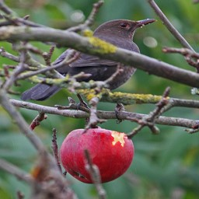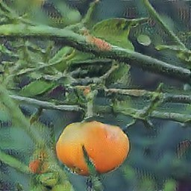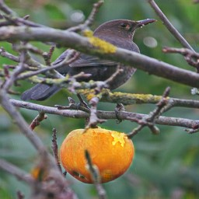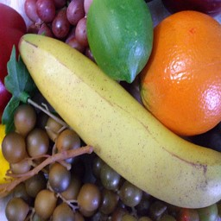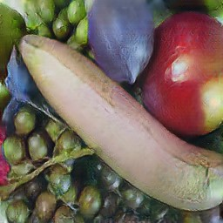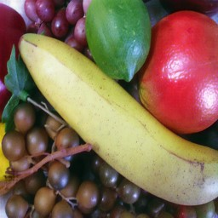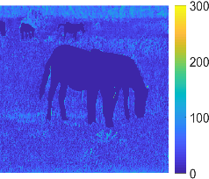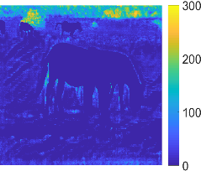

Fig. 2. Result comparisons for the translation of horse↔zebra and apple↔orange in MSCOCO dataset. From left to right: input samples, CycleGAN [17], difference maps of CycleGAN, AttentionGAN [51], difference maps of AttentionGAN, proposed and difference maps of proposed.

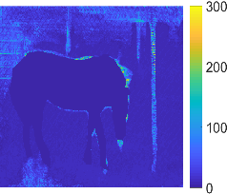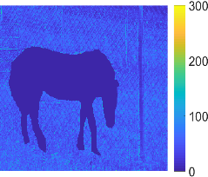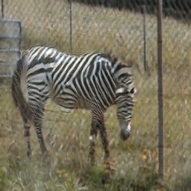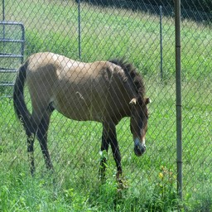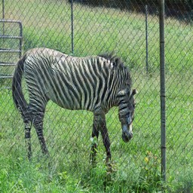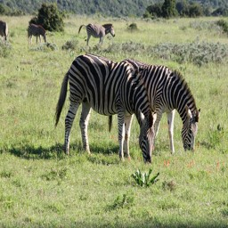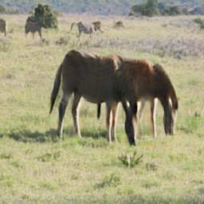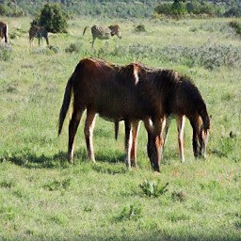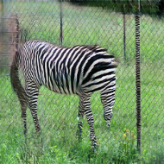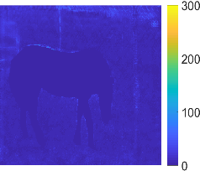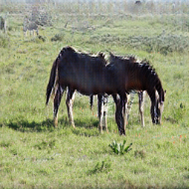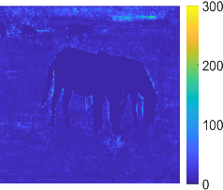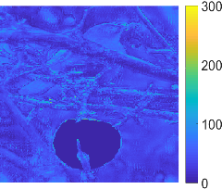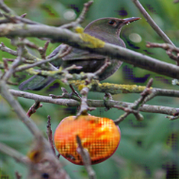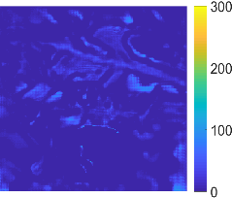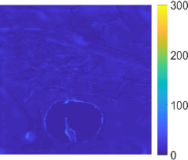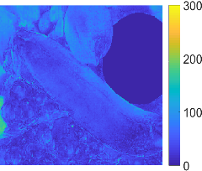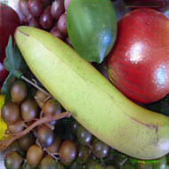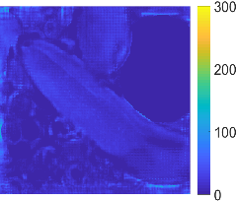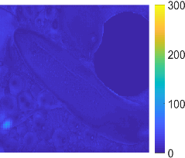

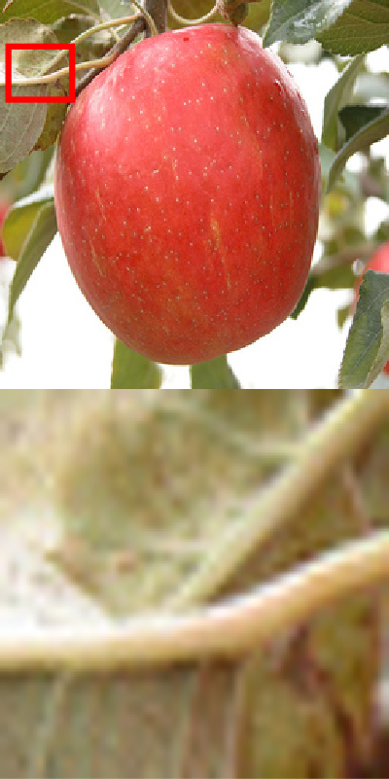 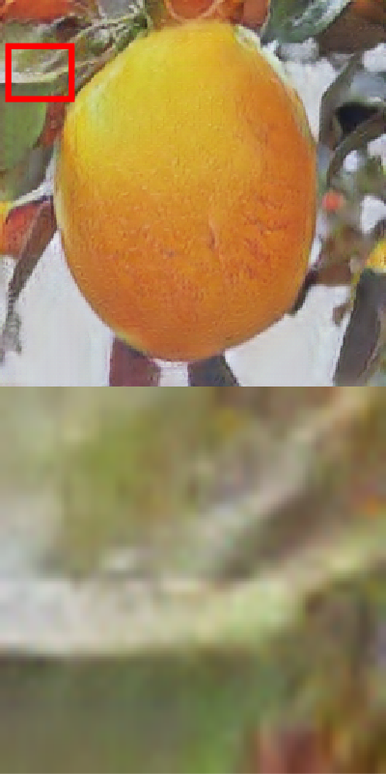 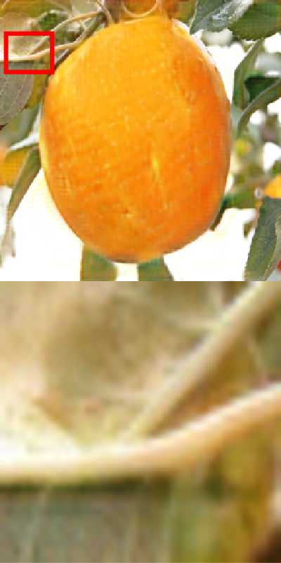 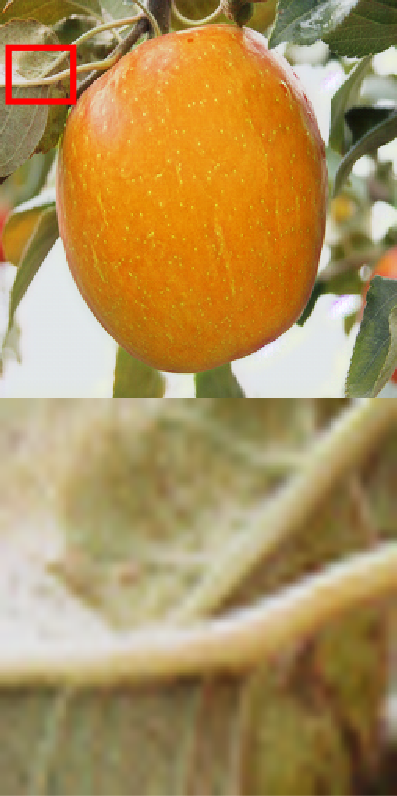

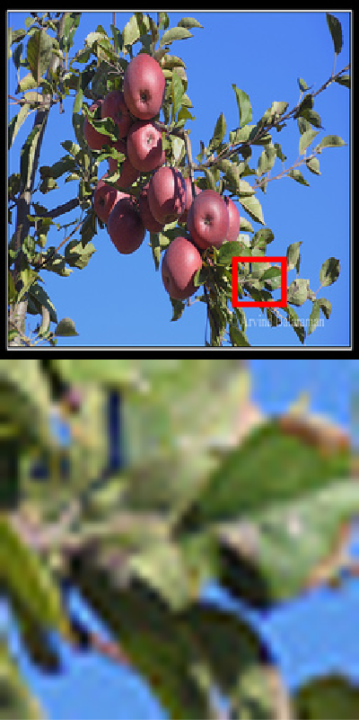 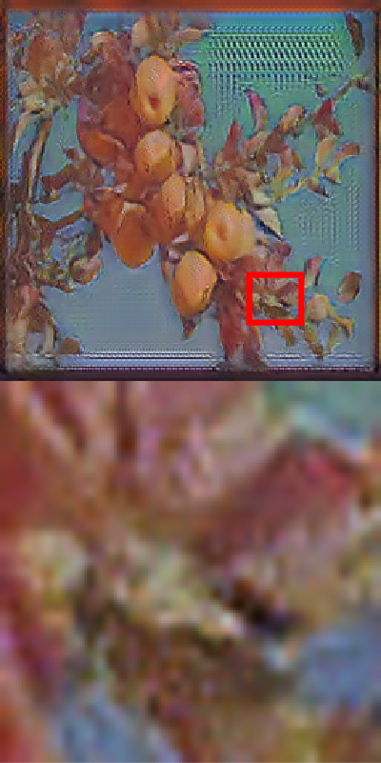 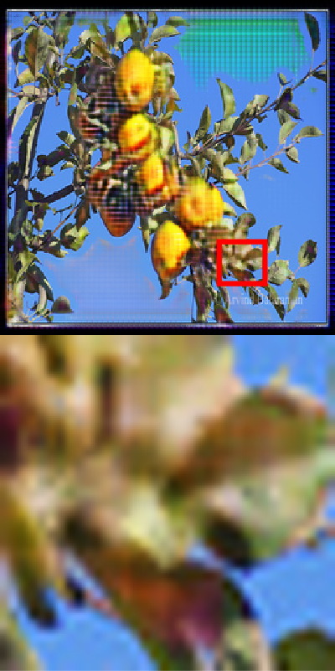 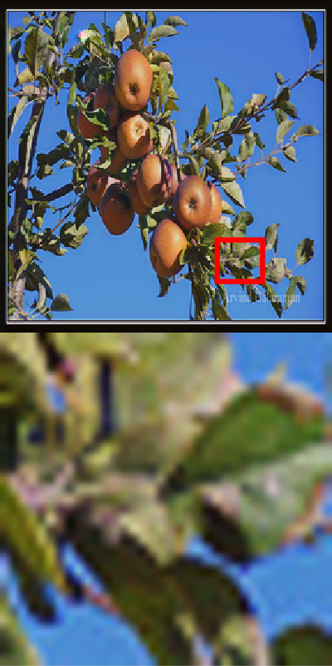

Fig. 3. Result comparisons for the translation of apple↔orange in ImageNet dataset. From left to right: input samples, CycleGAN [17], AttentionGAN [51] and proposed.

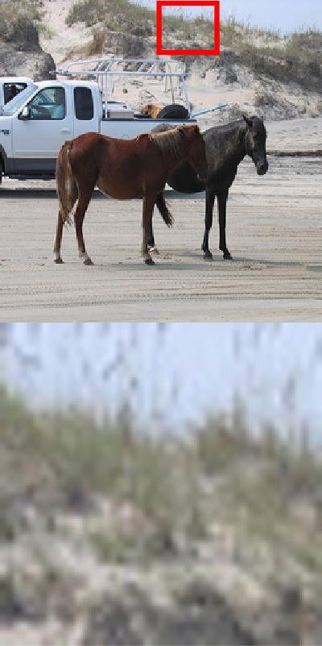 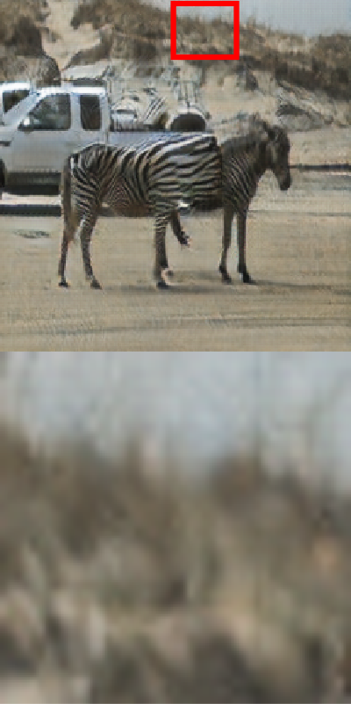 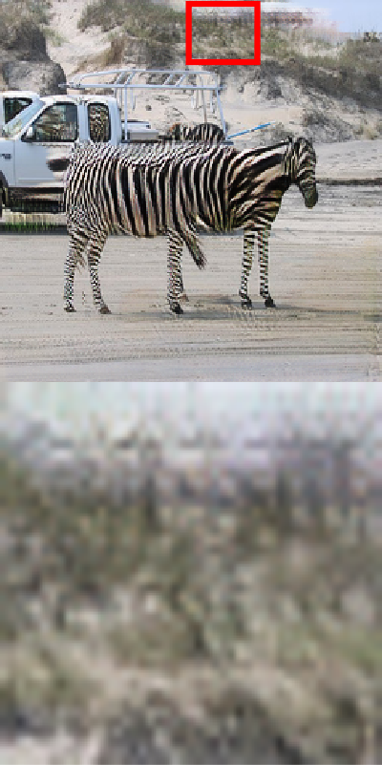 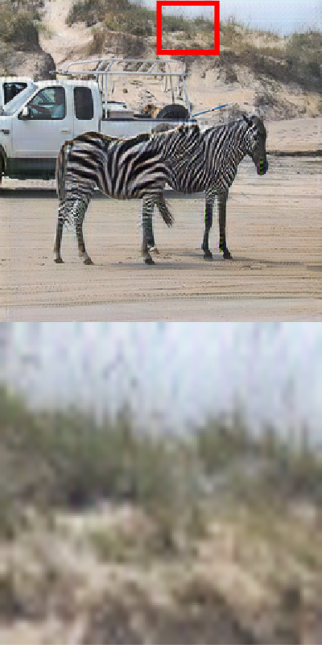

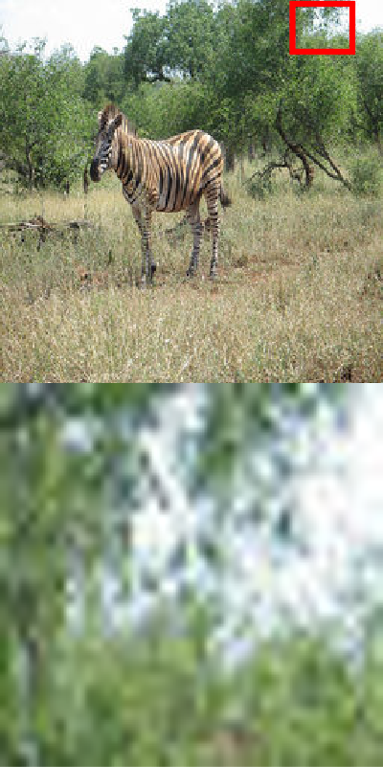 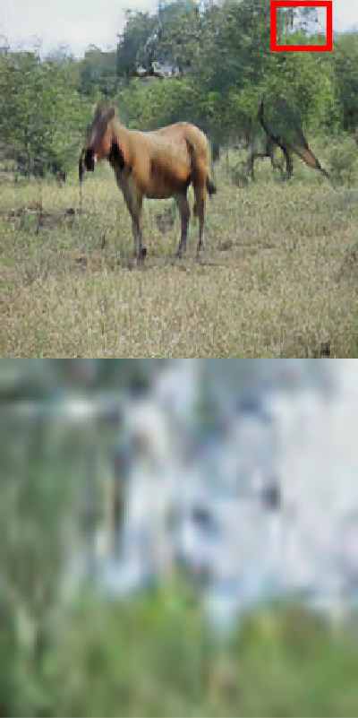 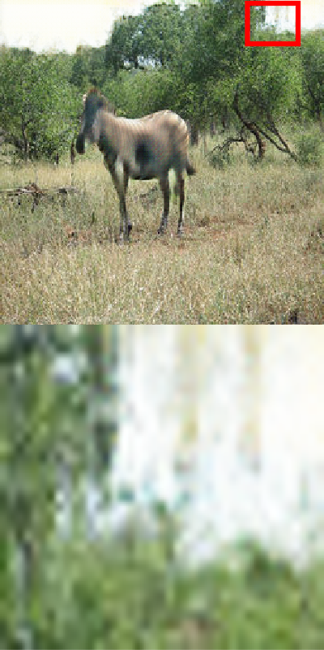 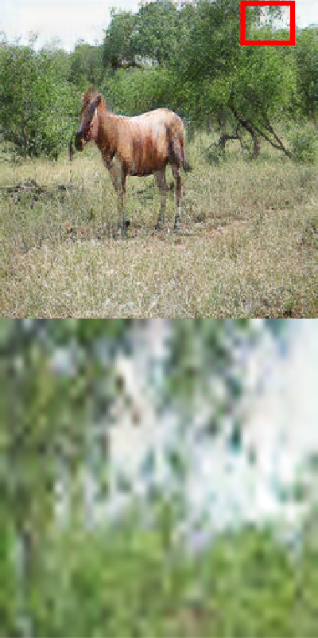

Fig. 4. Result comparisons for the translation of horse↔zebra in ImageNet dataset. From left to right: input samples, CycleGAN [17], AttentionGAN [51] and proposed.

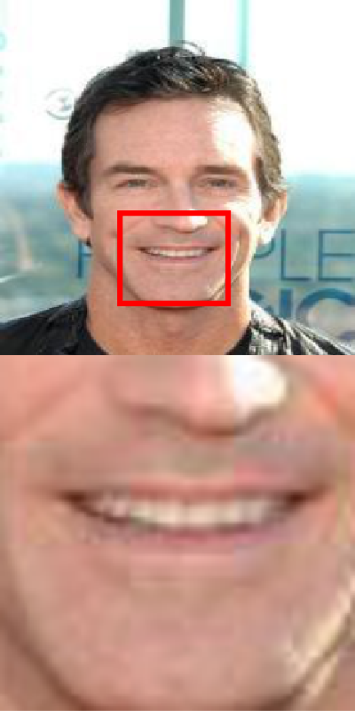 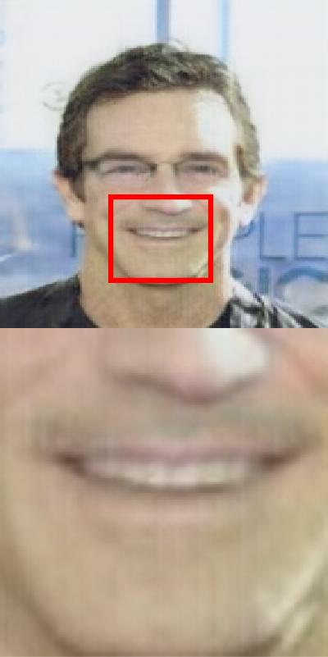 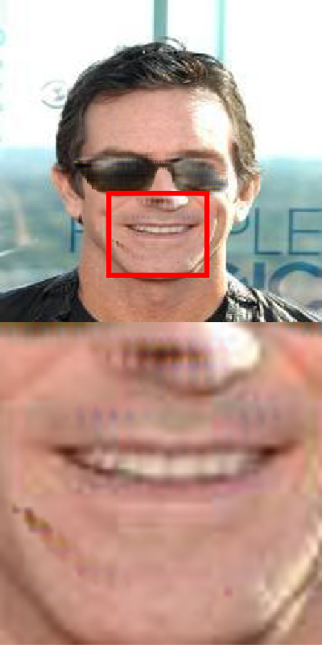 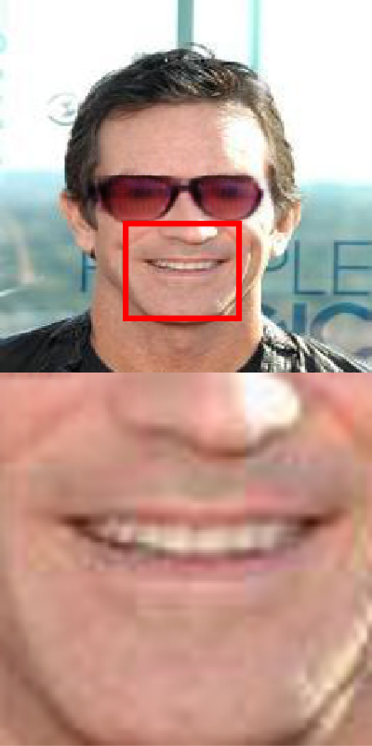

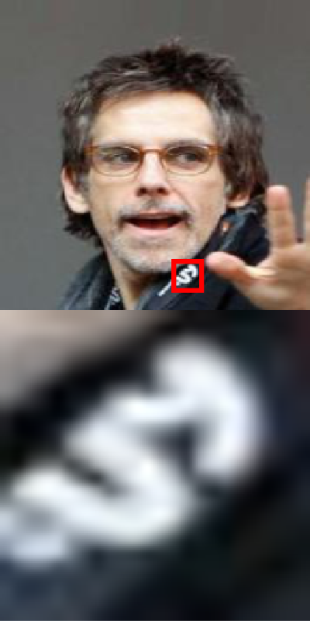 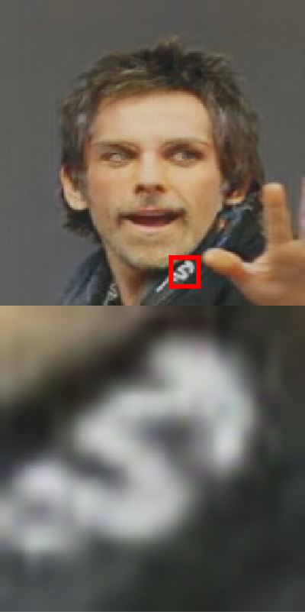 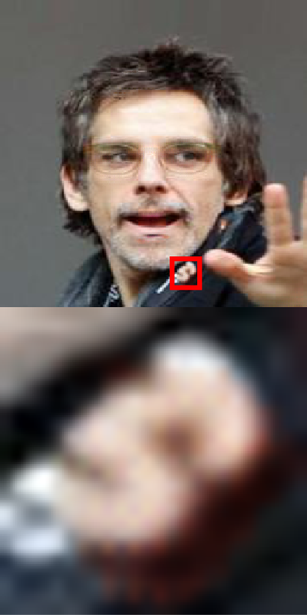 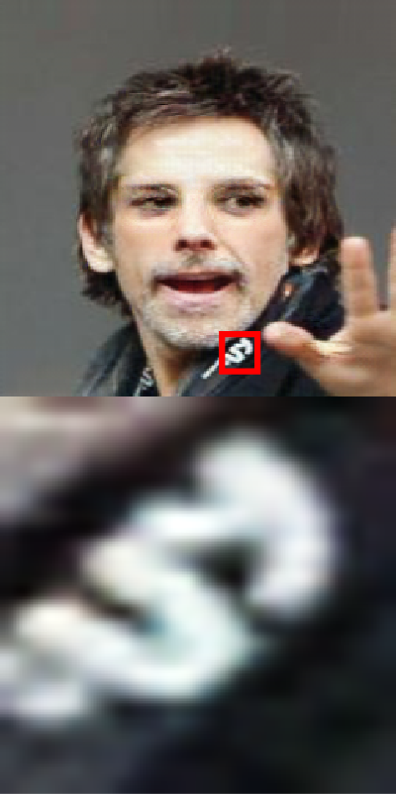

Fig. 5. Result comparisons for the translation of wearing glasses↔taking off glasses in CelebA dataset [49]. From left to right: input samples, CycleGAN [17], AttentionGAN [51] and proposed.

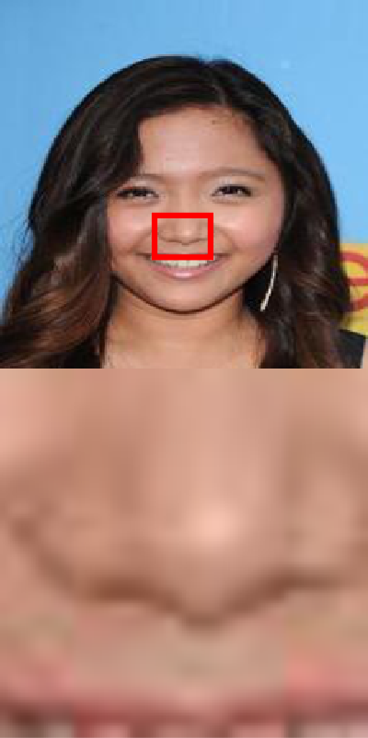 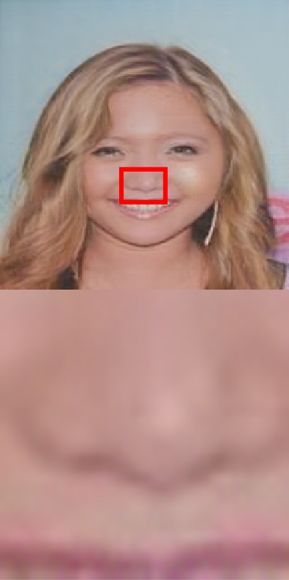 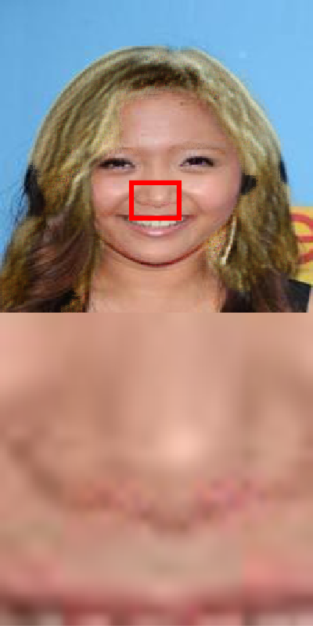 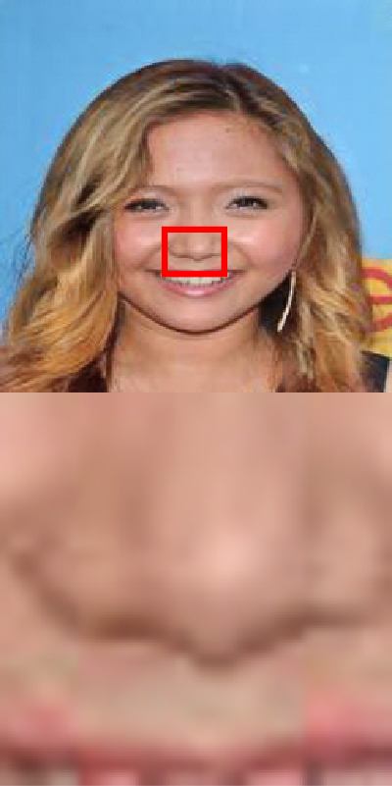

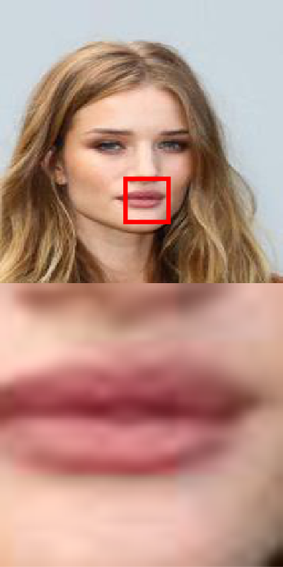 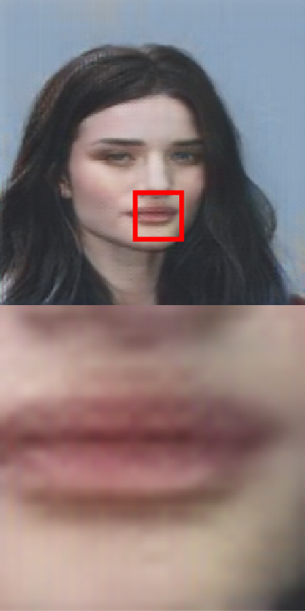 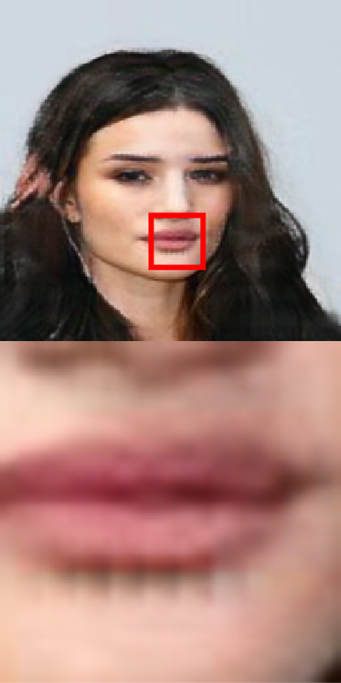 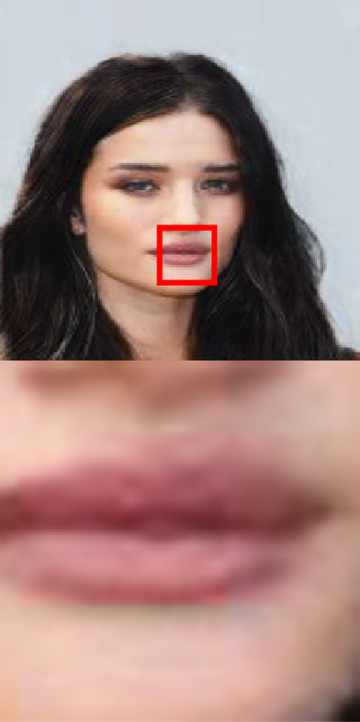

Fig. 6. Result comparisons for the translation of black hair↔blond hair in CelebA dataset [49]. From left to right: input samples, CycleGAN [17], AttentionGAN [51] and proposed.